**Prayer for the End of Human Trafficking through the Intercession of St. Josephine Bakhita**

**Father in heaven,**

May the faith you have given us in your Son, Jesus Christ,  
move us to defend the dignity of every human life  
and reawaken in us the blessed hope of a world free from oppression and slavery.

As you once led your servant, **St. Josephine Bakhita**,  
from the darkness of captivity to the light of faith,  
may your grace transform us into tireless defenders of justice.  
May we be bold in speaking for those who have no voice,  
compassionate in healing the wounds of the oppressed,  
and unwavering in our commitment to end human trafficking in all its forms.

May the seeds of your Gospel take root in the hearts of traffickers,  
bringing conversion where there is cruelty,  
mercy where there is greed,  
and repentance where there is exploitation.  
May those who suffer in slavery today   
find in your love the courage to hope,  
the strength to endure,  
and the freedom that is their birthright as children of God.

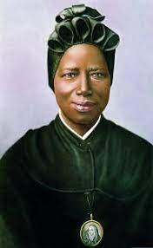May the grace of the Jubilee inspire in us, **Pilgrims of Hope**,  
a yearning for a world where no one is bought or sold,  
where every person is cherished as your beloved creation.  
Through the prayers of St. Josephine Bakhita,  
may joy, peace, and justice be sown across the earth,  
until that day when all chains are broken,  
all wounds are healed,  
and your glory shines eternally.

To you, our God, eternally blessed,  
be glory and praise forever.

**Amen.**

**February 6TH 2025 (BOT)**